EVENTHUB – EVENT BOOKING & MANAGEMENT PLATFORM
MAJOR PROJECT REPORT
Submitted By
Amritanshu Pandey
Course
Bachelor of Technology (B.Tech)
Semester
2nd Semester

CERTIFICATE
This is to certify that the project entitled “EventHub – Event Booking & Management Platform” submitted by Amritanshu Pandey in partial fulfillment of the requirements for the award of the degree of Bachelor of Technology is a bonafide work carried out under the guidance of the faculty supervisor.
The project has been completed successfully and fulfills the academic requirements prescribed by the institution.
Guide Signature: __________
Head of Department: __________
Date: __________

ACKNOWLEDGEMENT
I express my sincere gratitude to my project guide and faculty members for their continuous support, guidance, and encouragement throughout the development of this project.
I would also like to thank my institution for providing the necessary resources and learning environment. Finally, I thank my family and friends for their motivation and support during the completion of this project.

TABLE OF CONTANT

Topic | Pages
Cover page | 1
Certificate | 1
Acknowledgement | 1
Table of contant | 1
Abstract | 1
Introduction | 1
Literature Survey | 1
Objective | 1
Requirement | 1
Architecture | 1
Database | 1
Implementation | 5-7
Testing | 1
Future scope | 1
Conclusion | 1
References | 1
Total | 18-20

ABSTRACT
EventHub is a full-stack web application developed to simplify event management and ticket booking processes. The platform provides a centralized environment where administrators can create and manage events while users can browse events, view event details, and book tickets online.
The application is built using React.js for the frontend, Node.js and Express.js for the backend, and MongoDB Atlas for cloud database management. The system demonstrates the implementation of modern web technologies, RESTful APIs, database integration, and responsive user interface design.
EventHub enhances the user experience by providing a seamless booking process and efficient event management capabilities. The project highlights practical applications of full-stack web development concepts and serves as a scalable solution for event organizers and attendees.

CHAPTER 1: INTRODUCTION
1.1 Background
The growth of digital technologies has transformed the way events are organized and managed. Traditional event management methods often rely on manual registrations and physical ticketing systems, resulting in inefficiencies and limited accessibility.
EventHub addresses these challenges by providing an online platform that enables event creation, event discovery, and ticket booking through a user-friendly interface.
1.2 Problem Statement
Managing events manually can lead to difficulties in registration handling, ticket management, and communication between organizers and attendees.
There is a need for a centralized platform that simplifies event management while providing users with a convenient booking experience.
1.3 Objectives
- Develop a web-based event management system.
- Allow administrators to create and manage events.
- Enable users to browse and explore available events.
- Provide detailed event information.
- Implement online ticket booking functionality.
- Store event and booking data securely.
- Create a responsive and modern user interface.
CHAPTER 2: TECHNOLOGY STACK
Frontend Technologies
- React.js
- Vite
- JavaScript (ES6)
- CSS3
Backend Technologies
- Node.js
- Express.js
Database
- MongoDB Atlas
- Mongoose ODM
Development Tools
- Visual Studio Code
- Postman
- Git & GitHub

CHAPTER 3: LITERATURE SURVEY
Event management systems have become increasingly popular due to the growth of digital platforms and online services. Various event booking platforms such as Eventbrite and BookMyShow provide users with event discovery and ticket booking services. These platforms demonstrate the effectiveness of centralized event management solutions.
Several research studies highlight the importance of web-based management systems in reducing manual work and improving user experience. Cloud databases and modern frontend frameworks have further enhanced the scalability and responsiveness of such systems.
The EventHub project draws inspiration from existing event management platforms while implementing a simplified and educational version using the MERN technology stack. The project focuses on event creation, booking management, and database integration, providing practical exposure to modern web development practices.

CHAPTER 4: SYSTEM ARCHITECTURE
User
↓
React Frontend
↓
Express REST API
↓
Node.js Server
↓
MongoDB Atlas Database
The architecture follows a client-server model where the frontend communicates with backend APIs, and the backend manages data persistence through MongoDB Atlas.
CHAPTER 5: DATABASE DESIGN
Events Collection
Fields:
- _id
- title
- description
- category
- location
- date
- time
- image
- price
- rating
- organizer
Bookings Collection
Fields:
- _id
- eventId
- title
- location
- tickets
- price
- createdAt
CHAPTER 6: MODULES IMPLEMENTED
User Module
- Login Interface
- Registration Interface
- Event Browsing
- Event Details Viewing
- Ticket Booking
Admin Module
- Dashboard
- Create Event
- Event Management
Booking Module
- Ticket Selection
- Booking Confirmation
- Booking Storage
Database Module
- Event Storage
- Booking Storage
- Data Retrieval

CHAPTER 7: IMPLEMENTATION
Home Page
The Home Page displays featured events fetched from MongoDB and provides navigation throughout the platform.
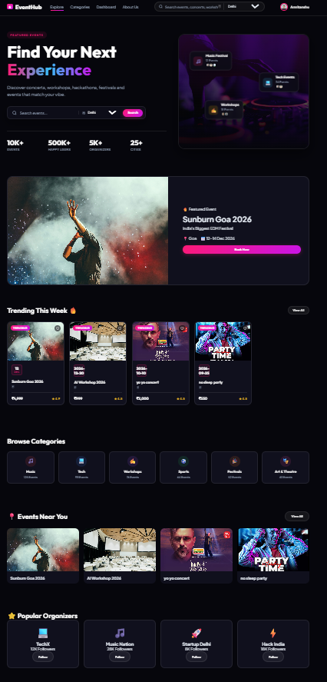
Event Details Page
Users can view complete event information, pricing details, venue information, and ticket options.
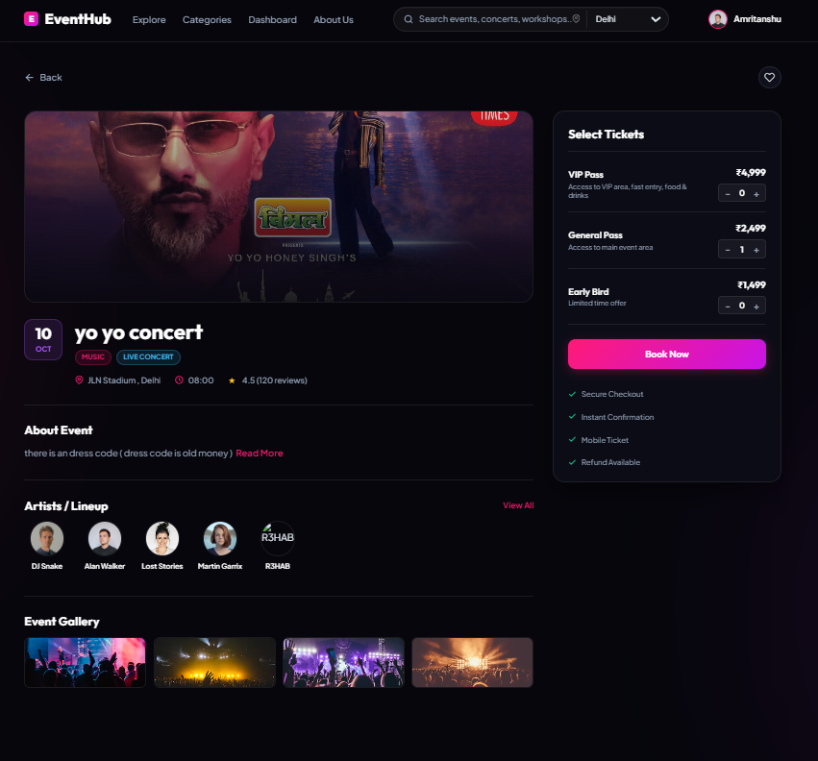
Admin Dashboard
The Admin Dashboard provides event management functionalities and system overview.
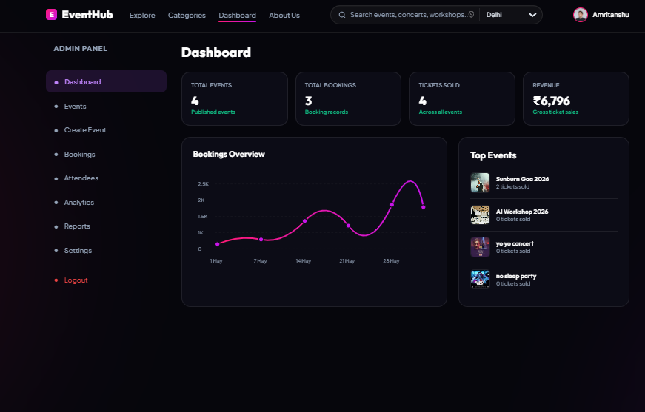
Create Event Page
Administrators can create new events which are stored in MongoDB Atlas.
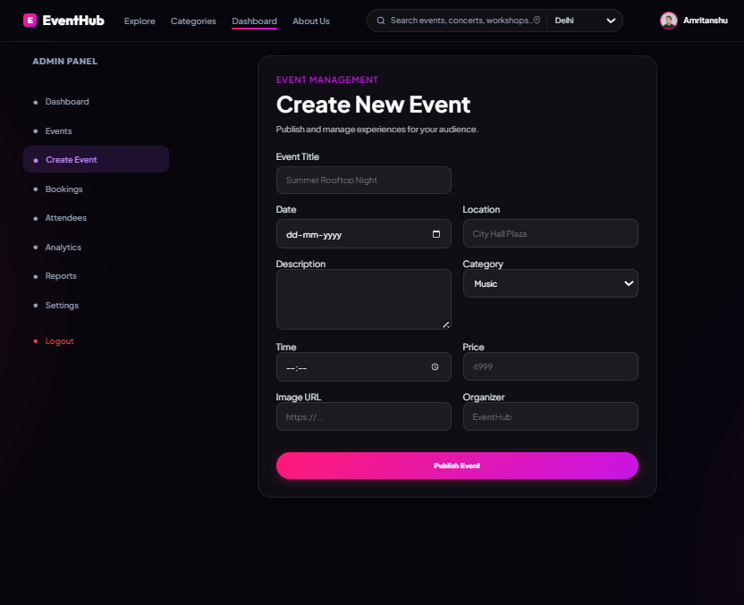
My Bookings Page
Users can view their booked events and ticket information.
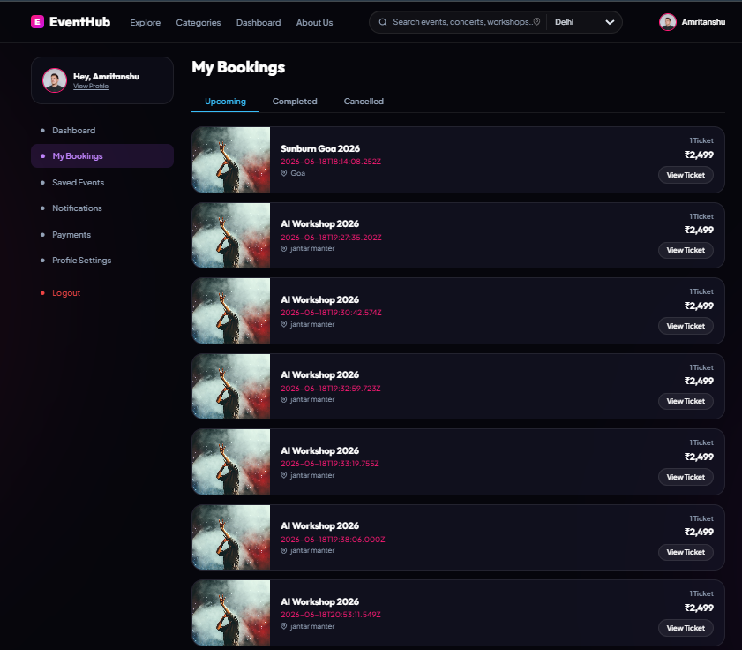
MongoDB Integration
Event and booking data are stored in MongoDB Atlas through REST APIs.
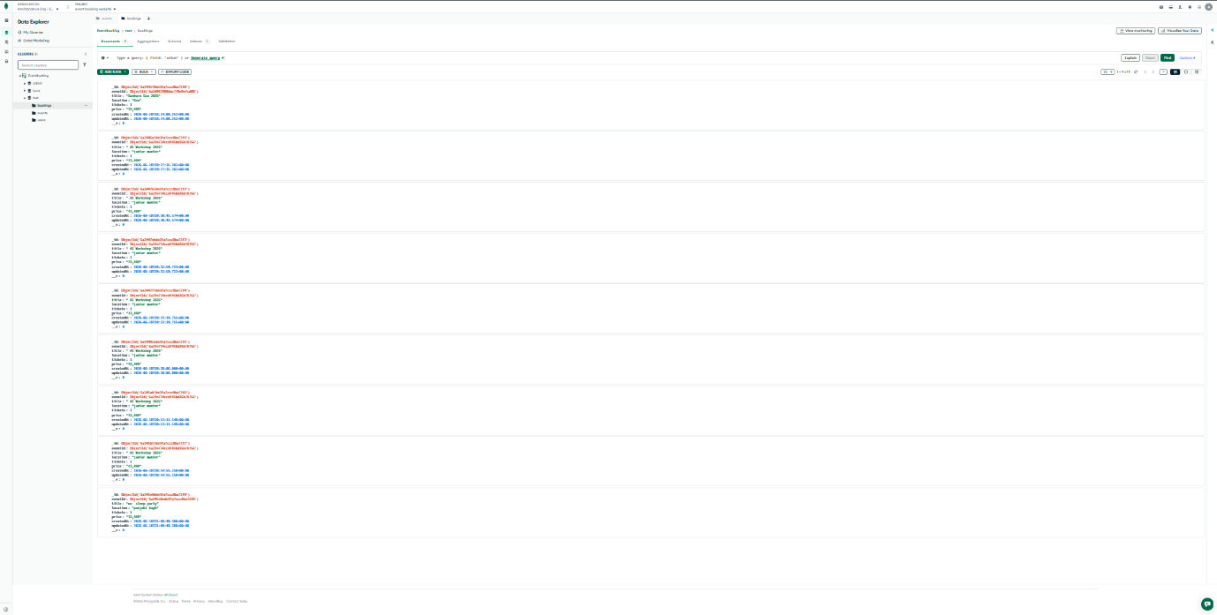
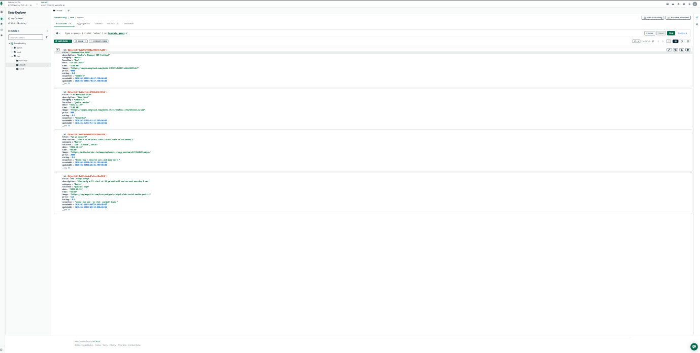
CHAPTER 8: TESTING
The following functionalities were tested successfully:
✓ Event Creation
✓ Event Storage in MongoDB
✓ Event Retrieval from Database
✓ Event Details Display
✓ Ticket Booking
✓ Booking Storage in MongoDB
✓ Booking Retrieval
✓ Dashboard Navigation
✓ Responsive Interface
CHAPTER 8: FUTURE SCOPE
- Online Payment Gateway Integration
- QR Code Ticket Generation
- Email Notifications
- Event Analytics Dashboard
- User Reviews and Ratings
- Advanced Search and Filtering
- Mobile Application Development
CHAPTER 9: CONCLUSION
EventHub successfully demonstrates the implementation of a modern event booking and management platform using full-stack web development technologies.
The project provides essential functionalities including event creation, event management, ticket booking, and database integration. The system is scalable, user-friendly, and suitable for further enhancement in real-world applications.
REFERENCES
- React.js Official Documentation
- Node.js Official Documentation
- Express.js Official Documentation
- MongoDB Atlas Documentation
- Mongoose Documentation
- MDN Web Documentation
- Vite Documentation

